Mirrors and Spoons
You have seen how mirrors and lenses interact with light in different ways to produce images. In this lesson you will investigate how an ordinary kitchen spoon interacts with light to form images.
You will also have the opportunity to research two of the most common eye conditions—nearsightedness and farsightedness—to find out what causes these conditions and how corrective lenses improve them.

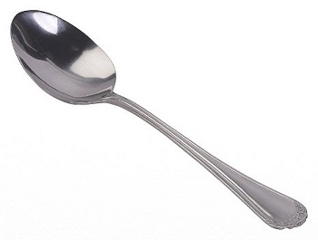

Vocabulary: Check Point
Review the module vocabulary you've encountered so far and check that you have learned the definitions for these words.
How well were you able to use cognates, synonyms, and antonyms to discover the meaning of three of the words? Try this example.

The child was adept at tying his shoelaces.

What does adept mean? Cognate: The English word adept and the Spanish word adepto both come from the Latin word adeptus, which means "achieved."
Synonyms: expert, skillful, proficient
Antonyms: inept, clumsy, unskilled

Now substitute a synonym for the word adept: The toddler was skillful at tying his shoelaces.
Regarding antonyms, you could say that the toddler was not clumsy or unskilled at tying his shoelaces.
Cognate: The word adept comes from the Latin word that means "achieved," so you could say: The toddler achieved the ability to tie his shoelaces.

Next, you will be working on a written assignment in which you will incorporate at least three of these vocabulary words.

Vocabulary Words

absorption
capacious
chlorophyll
cones
electromagnetic
medium
normal
optical density
photoreceptors
principal
profound
radiant energy
reflection
refraction
retina
rods
spectrum
transmission
visible

Lenses and Sight
What happens when you look at a spoon? Do you or does someone in your family wear glasses? How does the shape of a lens affect a person’s vision?

Study Club: Lenses and Sight

Screen 1

Convex Side of Spoon

Arnold: I first positioned the metal spoon so that the convex, back side is facing my friend Ben. We were both able to see his reflection face up in the spoon. It almost looked like a fun house picture!

Screen 2

Concave Side of Spoon

Arnold: Now I asked Ben to place the metal spoon with the concave, front side facing him. His reflection appears upside down in the spoon! So cool! I need to do some more research on how light is reflected off convex and concave surfaces and lenses.

Correcting Vision
Using the Internet, do some research on correcting nearsightedness and farsightedness. Make sure you find out how concave and convex lenses are used to correct these vision problems.
Reminder: Use reputable, well-known sources on the Internet for your search.

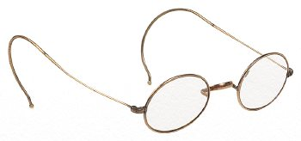

Assignment: Lenses and Sight Investigation
Use the observations to answer the questions in this assignment.

